I want to use 2 free late days.

Part1:

1. I change MAX_ITER to 1000
2. Learning rate, iterations, and batch size.
3. iter: 999 total_loss: 0.807

| AP | AP50 | AP75 | APs | APm | APl |

| 28.787 | 50.151 | 30.846 | 19.500 | 37.073 | 58.116 |

1. 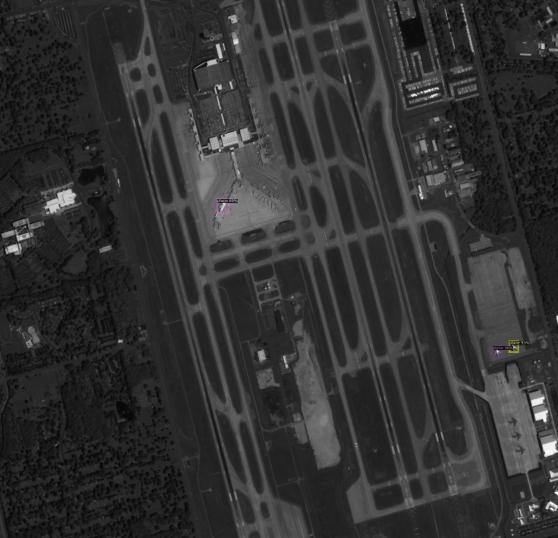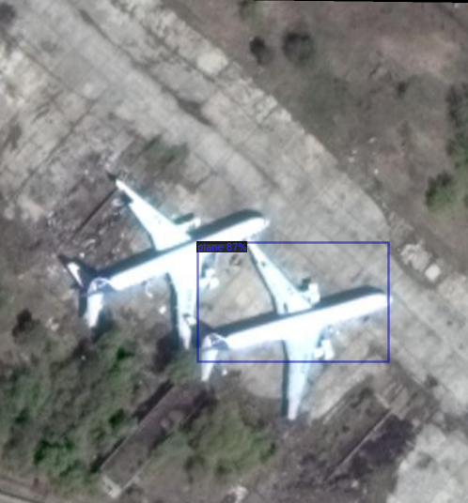

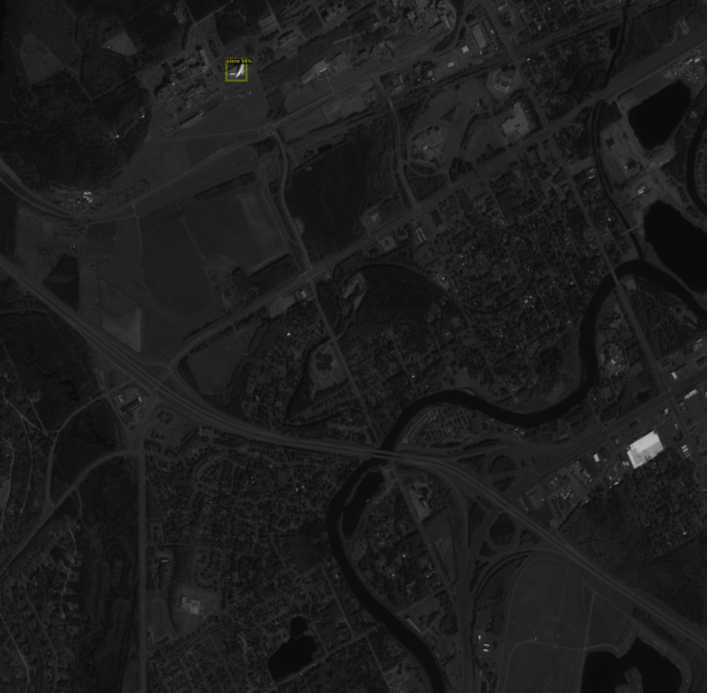

1. I got 50.151 for AP50 score after I change MAX_ITER to 1000, which is higher than 500 iterations.

Part2:

1. num_epochs = 5

batch_size = 4

learning_rate = 0.005

optimizer: SGD

1. Network include conv layer, conv layer with max-pooling and conv layer with upsampling, this is the default network without modification.
2. Loss function: nn.BCEWithLogitsLoss()
3. Mean IoU: 0.6268263284199577
4. 

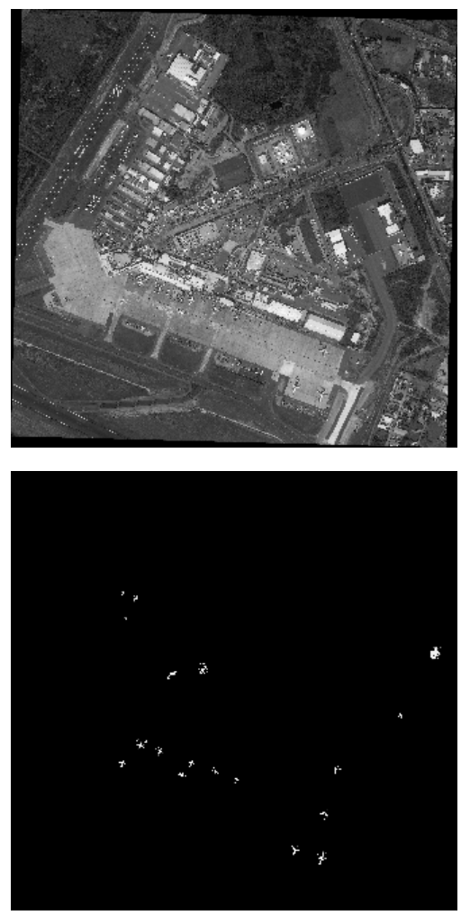Part3:

1. Name: TonyHuang42
2. 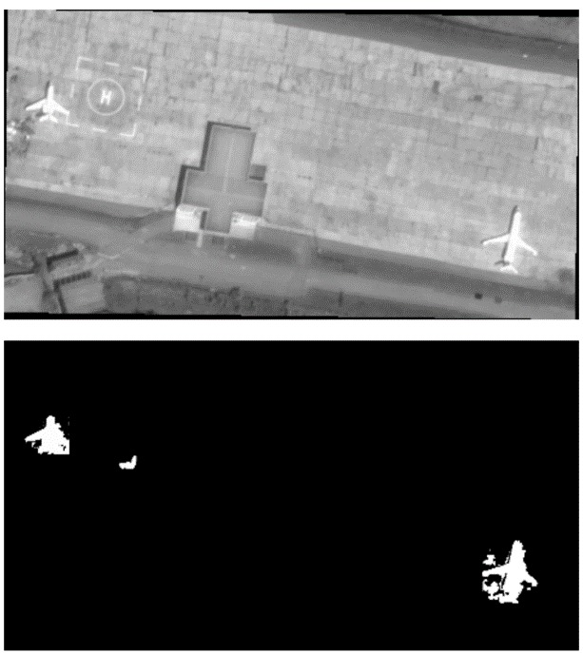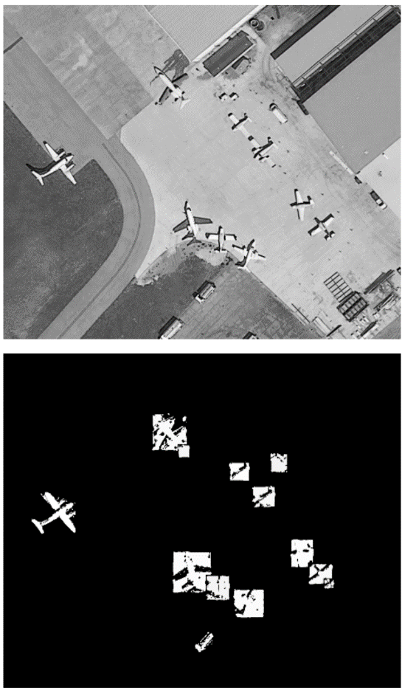Score: 0.22249

Part4:

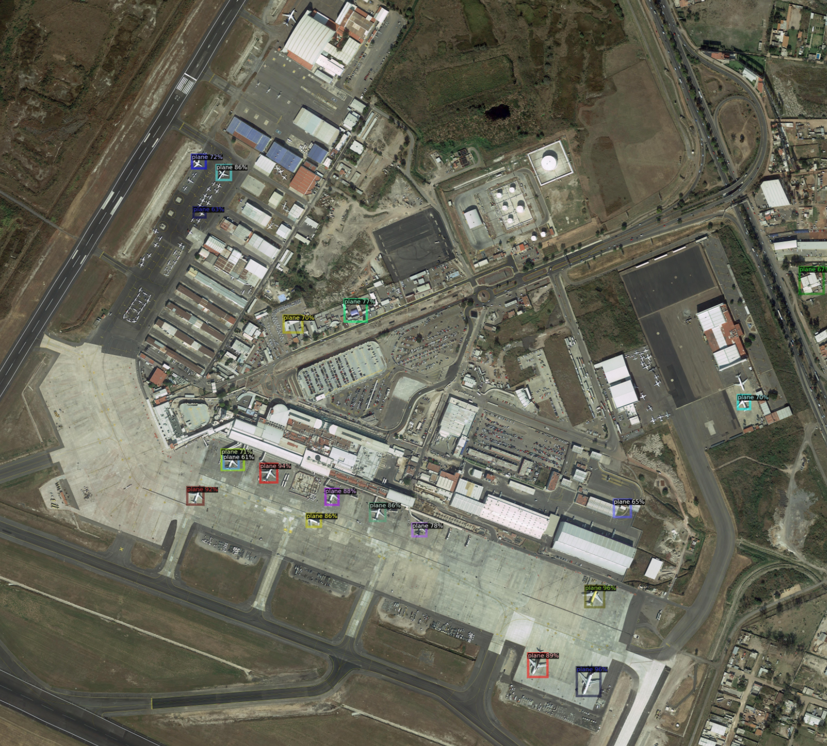

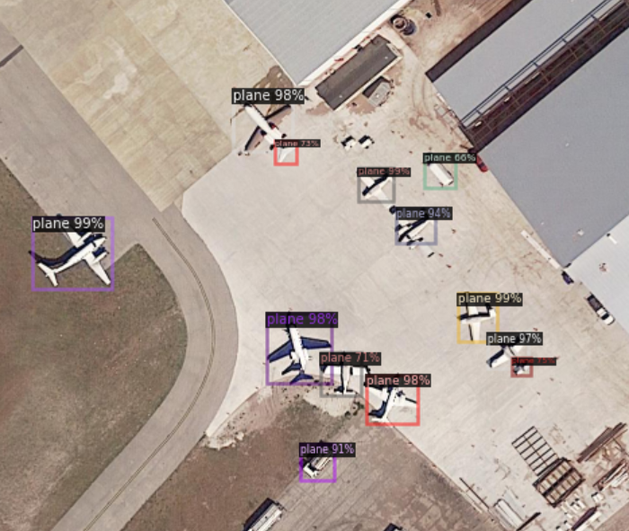

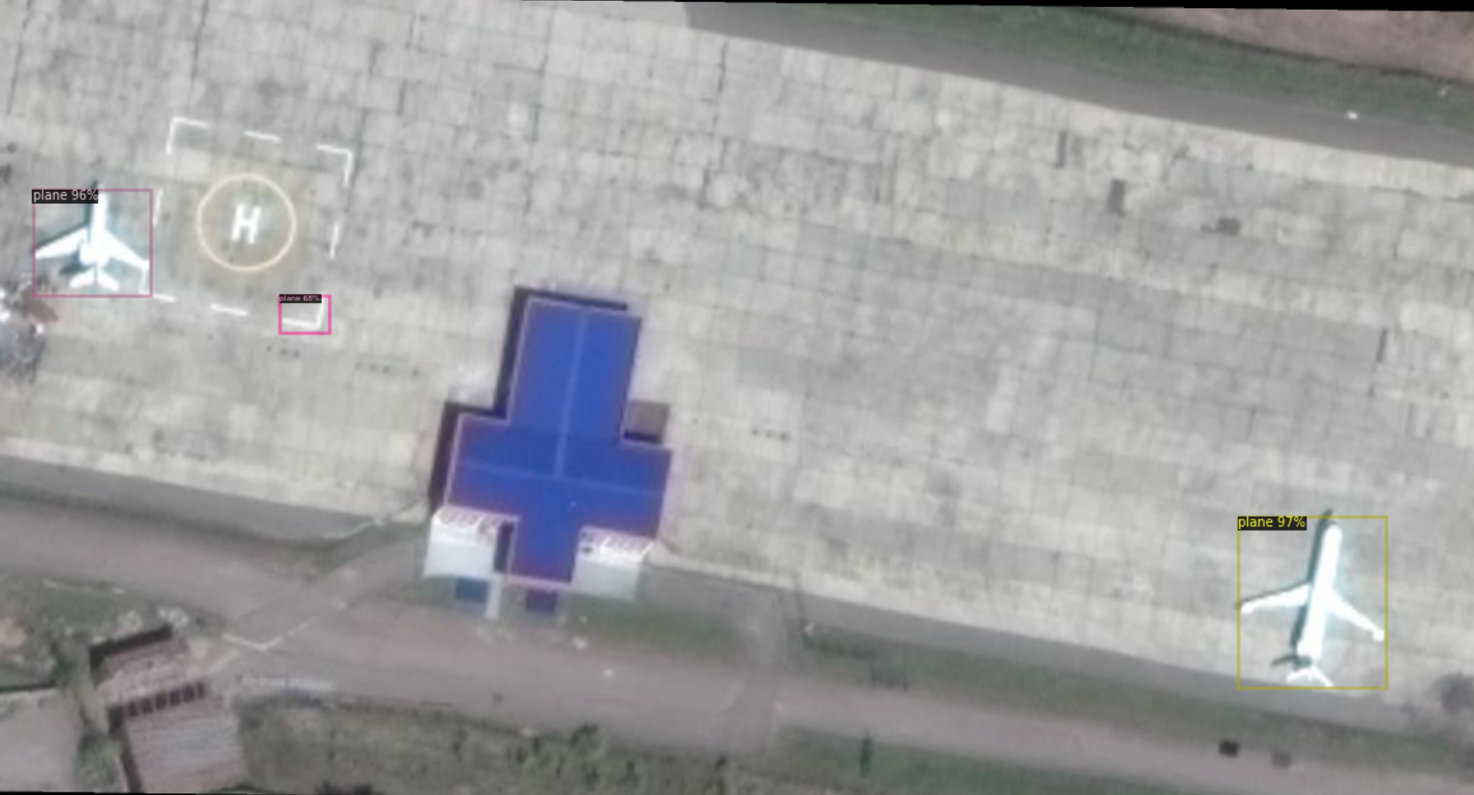

iter: 999 total_loss: 1.057

| AP | AP50 | AP75 | APs | APm | APl |

| 28.237 | 50.024 | 29.018 | 18.436 | 36.144 | 56.463 |

The prediction of part3 for mask is more accurate than part4, both predictions’ bounding box are similar.

Citation:

I discussed this assignment with Richard Chen, Roman Zhu, and Mak Nontawat.